|  |  |  |
| --- | --- | --- |
|  | **PORTFOLIO PROJECT** |  |

Submitted by **PRATHEEP 1P24MC036**

In partial fulfillment of the requirements for the award of the Degree of

#### MASTER OF COMPUTER APPLICATIONS

From Bharathiar University, Coimbatore.

Under the Internal Supervision of

**Mrs. Dr. S RANJITHA KUMARI, M.Sc., M.Phil., Ph.D.**

Associate Professor, Dept. of MCA, RVSCAS



**SCHOOL OF COMPUTER STUDIES MASTER OF COMPUTER APPLICATIONS**

**RVS COLLEGE OF ARTS AND SCIENCE (AUTONOMOUS)**

**Sulur , Coimbatore – 641 402.**

**Nov 2024**

# RVS COLLEGE OF ARTS AND SCIENCE (AUTONOMOUS)

**Sulur, Coimbatore – 641 402. School of Computer Studies**

**Department of Computer Applications (MCA)**



#### Nov 2024.

**Register Number: 1P24MC036**

Certified bonafideoriginal record of work done by **PRATHEEP T**

**Internal Supervisor Director**

Submitted for the project Evaluation and Viva voceheld on**………………….**

**Internal Examiner External Examiner**

# CONTENT INDEX

|  |  |
| --- | --- |
| **Chapter** | **Page No.** |
| **Chapter 1**: Home   * 1. Name & Description   2. Self Intro | 1 |
| **Chapter 2:** Website Bio Score   * 1. About me | 5 |
| **Chapter 3**: Pages & Navigation   * 1. Landing Page      1. Responsive Query   2. Project Page   3. Navigation bar   4. Education   5. Skills | 20 |
| **Chapter 4**: Style Score   * 1. Style links | 60 |

|  |  |
| --- | --- |
| **Chapter 5**: Website include the following Information   * 1. Project link to the GitHub   2. Project Description | 62 |
| **Chapter 6**: Bootstrap   * 1. Uses of Bootstrap | 52 |
| **Chapter 7**: Project README & LICENSE  Title description  How to run the project  Future improvement in the Project | 55 |

**Chapter-1**

**Name & Description**

**1.1 Name & Description.**

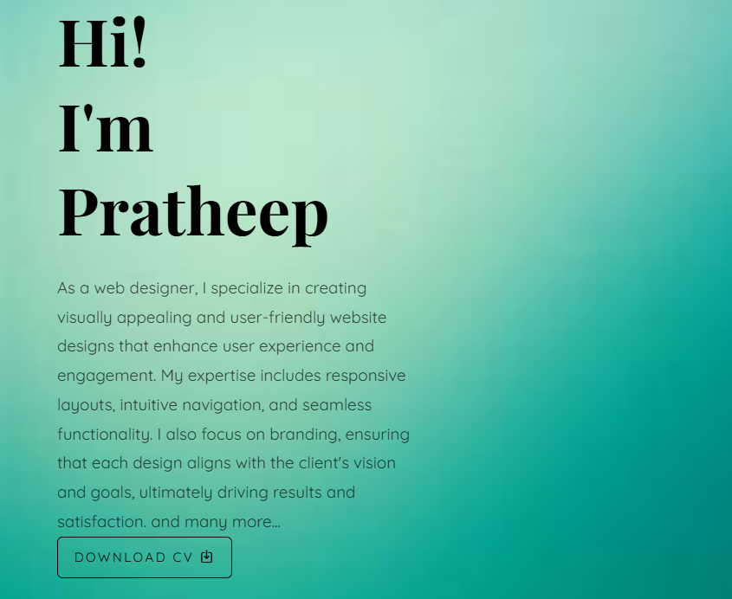

# 

# Description:

In this page, you can see the name & download CV of mine. If you want you see my CV click on download CV and see it and other page can include my design works how I interested in it.

**Source Code:**

## HTML:

<div id="colorlib-main">

<section id="colorlib-hero" class="js-fullheight" data-section="home">

<div class="flexslider js-fullheight">

<ul class="slides">

<li style="background-image: url(images/bg\ 1.jpg);">

<div class="overlay"></div>

<div class="container-fluid">

<div class="row">

<div class="col-md-6 col-md-offset-3 col-md-pull-3 col-sm-12 col-xs-12 js-fullheight slider-text">

<div class="slider-text-inner js-fullheight">

<div class="desc">

<h1>Hi! <br>I'm Pratheep</h1>

<p>As a web designer, I specialize in creating visually appealing and user-friendly website designs that enhance user experience and engagement. My expertise includes responsive layouts, intuitive navigation, and seamless functionality. I also focus on branding, ensuring that each design aligns with the client's vision and goals, ultimately driving results and satisfaction. and many more...</p>

<p><a href="Pratheep CV.pdf" download class="btn btn-primary btn-learn">

Download CV <i class="icon-download4"></i>

</a></p>

</div>

</div>

</div>

</div>

</div>

</li>

<li style="background-image: url(images/bg\ 2.jpg);">

<div class="overlay"></div>

<div class="container-fluid">

<div class="row">

<div class="col-md-6 col-md-offset-3 col-md-pull-3 col-sm-12 col-xs-12 js-fullheight slider-text">

<div class="slider-text-inner">

<div class="desc">

<h1>I am <br>a Designer</h1>

<p>As a web designer, I excel in crafting aesthetically pleasing and user-centric website designs that improve user experience and foster engagement. My skills encompass adaptive layouts, clear navigation, and smooth functionality. I also prioritize branding, ensuring that each design reflects the client’s vision and objectives, ultimately achieving desired outcomes and client satisfaction. Additionally, I offer a variety of other services...</p>

</div>

</div>

</div>

</div>

</div>

</li>

</ul>

</div>

</section>

**1.2 Self Intro**

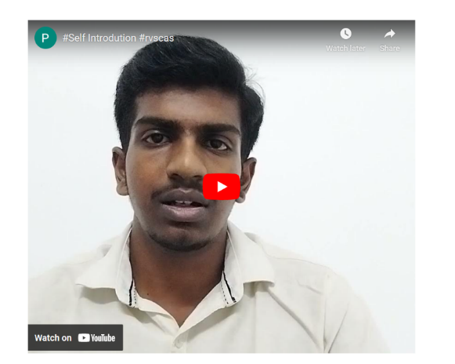

**Source Code:**

## HTML:

<!--==================== SELF INTRO ====================-->

          </section>

        <section id="colorlib-hero" class="js-fullheight" data-section="self">

            <div class="video-container" id="self">

<iframwidth="700" height="600" src="https://www.youtube.com/embed/opGK4380cyE?si=8SyAFY8DjbFH993U" title="YouTube video player" frameborder="0" allow="accelerometer; autoplay; clipboard-write; encrypted-media; gyroscope; picture-in-picture; web-share" referrerpolicy="strict-origin-when-cross-origin" allowfullscreen></iframe>

</div></section>

## CSS:

## <!--==================== SELF INTRO ====================-->

.video-container {

      text-align: center; /* Center the iframe */

      margin-top: 20px;  /* Add some space above */

  }

  .video-container iframe {

      max-width: 100%;    /* Make it responsive */

            /* Maintain aspect ratio */

  }

# Chapter-2:

**Website Bio Score**

* 1. **About Me:**

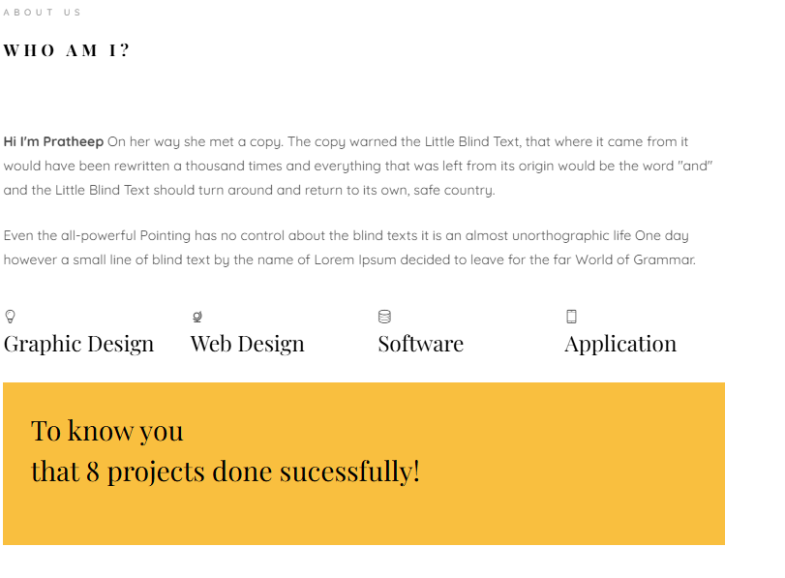

**Description:**

In this page, there is an image of mine, paragraph about me and also an option to see my interested area and how many projects done successfully.

**Source Code:**

## HTML:

<!--==================== ABOUT ====================-->

<section class="colorlib-about" data-section="about">

<div class="colorlib-narrow-content">

<div class="row">

<div class="col-md-12">

<div class="row row-bottom-padded-sm animate-box" data-animate-effect="fadeInLeft">

<div class="col-md-12">

<div class="about-desc">

<span class="heading-meta">About Us</span>

<h2 class="colorlib-heading">Who Am I?</h2>

<p><strong>Hi I'm Pratheep</strong> On her way she met a copy. The copy warned the Little Blind Text, that where it came from it would have been rewritten a thousand times and everything that was left from its origin would be the word "and" and the Little Blind Text should turn around and return to its own, safe country.</p>

<p>Even the all-powerful Pointing has no control about the blind texts it is an almost unorthographic life One day however a small line of blind text by the name of Lorem Ipsum decided to leave for the far World of Grammar.</p>

</div>

</div>

</div>

<div class="row">

<div class="col-md-3 animate-box" data-animate-effect="fadeInLeft">

<div class="services color-1">

<span class="icon2"><i class="icon-bulb"></i></span>

<h3>Graphic Design</h3>

</div>

</div>

<div class="col-md-3 animate-box" data-animate-effect="fadeInRight">

<div class="services color-2">

<span class="icon2"><i class="icon-globe-outline"></i></span>

<h3>Web Design</h3>

</div>

</div>

<div class="col-md-3 animate-box" data-animate-effect="fadeInTop">

<div class="services color-3">

<span class="icon2"><i class="icon-data"></i></span>

<h3>Software</h3>

</div>

</div>

<div class="col-md-3 animate-box" data-animate-effect="fadeInBottom">

<div class="services color-4">

<span class="icon2"><i class="icon-phone3"></i></span>

<h3>Application</h3>

</div>

</div>

</div>

<div class="row">

<div class="col-md-12 animate-box" data-animate-effect="fadeInLeft">

<div class="hire">

<h2>To know you <br>that 8 projects done sucessfully!</h2>

</div>

</div>

</div>

</div>

</div>

</div>

</section>

## CSS:

/*=============== ABOUT ===============*/

.about-img {

  width: 100%;

  height: 600px;

  margin-bottom: 30px; }

.about-desc h3 {

  font-size: 18px;

  text-transform: uppercase;

  letter-spacing: 5px;

  font-weight: 500; }

.fancy-collapse-panel .panel-default > .panel-heading {

  padding: 0; }

.panel-heading a {

  padding: 20px 25px;

  display: block;

  width: 100%;

  font-weight: 500;

  font-size: 14px;

  letter-spacing: 1px;

  text-transform: uppercase;

  font-family: "Quicksand", Arial, sans-serif;

  background-color: #2c98f0;

  color: #fff;

  position: relative;

  -webkit-box-shadow: none !important;

  -moz-box-shadow: none !important;

  -ms-box-shadow: none !important;

  -o-box-shadow: none !important;

  box-shadow: none !important; }

.panel {

  -webkit-box-shadow: none !important;

  -moz-box-shadow: none !important;

  -ms-box-shadow: none !important;

  -o-box-shadow: none !important;

  box-shadow: none !important;

  border: none; }

.panel-heading a:after {

  font-family: "icomoon";

  content: "\e115";

  position: absolute;

  right: 20px;

  font-size: 14px;

  font-weight: 400;

  top: 50%;

  line-height: 1;

  margin-top: -7px; }

.panel-heading a.collapsed:after {

  content: "\e114"; }

.panel-heading a.collapsed {

  background: #f2f3f7;

  border: 1px solid #e6e6e6 !important;

  color: #333333; }

.panel-body {

  padding: 1.5em;

  margin-top: 5px;

  border: 1px solid #e6e6e6 !important; }

.timeline-centered {

  position: relative;

  margin-bottom: 30px; }

.timeline-centered:before, .timeline-centered:after {

  content: " ";

  display: table; }

.timeline-centered:after {

  clear: both; }

.timeline-centered:before, .timeline-centered:after {

  content: " ";

  display: table; }

.timeline-centered:after {

  clear: both; }

.timeline-centered:before {

  content: '';

  position: absolute;

  display: block;

  width: 4px;

  background: #f2f3f7;

  top: 20px;

  bottom: 20px;

  margin-left: 29px; }

.timeline-centered .timeline-entry {

  position: relative;

  margin-top: 5px;

  margin-left: 30px;

  margin-bottom: 10px;

  clear: both; }

.timeline-centered .timeline-entry .timeline-entry-inner {

  position: relative;

  margin-left: -20px; }

.timeline-centered .timeline-entry .timeline-entry-inner .timeline-icon {

  display: block;

  width: 40px;

  height: 40px;

  background: #2c98f0;

  -webkit-border-radius: 50%;

  -moz-border-radius: 50%;

  -ms-border-radius: 50%;

  border-radius: 50%;

  text-align: center;

  -moz-box-shadow: 0 0 0 5px #f2f3f7;

  -webkit-box-shadow: 0 0 0 5px #f2f3f7;

  box-shadow: 0 0 0 5px #f2f3f7;

  line-height: 40px;

  float: left; }

.timeline-centered .timeline-entry .timeline-entry-inner .timeline-icon i {

    color: #fff; }

  .timeline-centered .timeline-entry .timeline-entry-inner .timeline-icon.color-2 {

    background: #ec5453; }

  .timeline-centered .timeline-entry .timeline-entry-inner .timeline-icon.color-3 {

    background: #f9bf3f; }

  .timeline-centered .timeline-entry .timeline-entry-inner .timeline-icon.color-4 {

    background: #a84cb8; }

  .timeline-centered .timeline-entry .timeline-entry-inner .timeline-icon.color-5 {

    background: #2fa499; }

  .timeline-centered .timeline-entry .timeline-entry-inner .timeline-icon.color-none {

    background: #fff;

    width: 20px;

    height: 20px;

    margin-left: 10px; }

.timeline-centered .timeline-entry .timeline-entry-inner .timeline-label {

  position: relative;

  background: #f2f3f7;

  padding: 1.5em;

  margin-left: 60px;

  -webkit-background-clip: padding-box;

  -moz-background-clip: padding;

  background-clip: padding-box; }

.timeline-centered .timeline-entry .timeline-entry-inner .timeline-label:after {

  content: '';

  display: block;

  position: absolute;

  width: 0;

  height: 0;

  border-style: solid;

  border-width: 9px 9px 9px 0;

  border-color: transparent #f2f3f7 transparent transparent;

  left: 0;

  top: 10px;

  margin-left: -9px; }

.timeline-centered .timeline-entry .timeline-entry-inner .timeline-label p + p {

  margin-top: 15px; }

.timeline-centered .timeline-entry .timeline-entry-inner .timeline-label h2 {

  font-size: 20px;

  font-family: "Quicksand", Arial, sans-serif;

  font-weight: 500; }

.timeline-centered .timeline-entry .timeline-entry-inner .timeline-label h2 a {

  color: #000; }

.timeline-centered .timeline-entry .timeline-entry-inner .timeline-label h2 span {

  -webkit-opacity: .4;

  -moz-opacity: .4;

  opacity: .4;

  -ms-filter: alpha(opacity=40);

  filter: alpha(opacity=40);

  font-size: 16px; }

* 1. **Contact Page :**

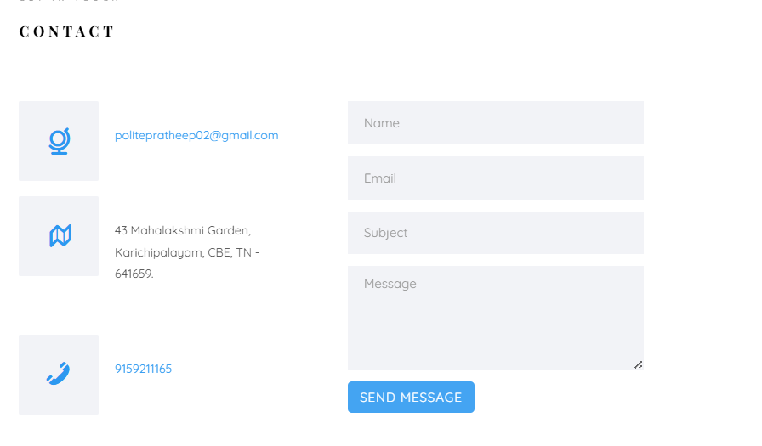

**Description:**

The above displayed figure is a contact page in the website. If the user wants to contact me, they can fill the form with their valid details. Here I imported library called Email-js to send messages.

**Source Code:**

## HTML:

<!--==================== CONTACT ====================-->

<section class="colorlib-contact" data-section="contact">

<div class="colorlib-narrow-content">

<div class="row">

<div class="col-md-6 col-md-offset-3 col-md-pull-3 animate-box" data-animate-effect="fadeInLeft">

<span class="heading-meta">Get in Touch</span>

<h2 class="colorlib-heading">Contact</h2>

</div>

</div>

<div class="row">

<div class="col-md-5">

<div class="colorlib-feature colorlib-feature-sm animate-box" data-animate-effect="fadeInLeft">

<div class="colorlib-icon">

<i class="icon-globe-outline"></i>

</div>

<div class="colorlib-text">

<p><a href="mailto:info@domain.com">politepratheep02@gmail.com</a></p>

</div>

</div>

<div class="colorlib-feature colorlib-feature-sm animate-box" data-animate-effect="fadeInLeft">

<div class="colorlib-icon">

<i class="icon-map"></i>

</div>

<div class="colorlib-text">

<p>43 Mahalakshmi Garden, Karichipalayam, CBE, TN - 641659.</p>

</div>

</div>

<div class="colorlib-feature colorlib-feature-sm animate-box" data-animate-effect="fadeInLeft">

<div class="colorlib-icon">

<i class="icon-phone"></i>

</div>

<div class="colorlib-text">

<p><a href="tel:+1234567890">9159211165</a></p>

</div>

</div>

</div>

<div class="col-md-7 col-md-push-1">

<div class="row">

<div class="col-md-10 col-md-offset-1 col-md-pull-1 animate-box" data-animate-effect="fadeInRight">

<form id="contact-form">

<div class="form-group">

<input type="text" id="name" class="form-control" placeholder="Name" required>

</div>

<div class="form-group">

<input type="email" id="email" class="form-control" placeholder="Email" required>

</div>

<div class="form-group">

<input type="text" id="subject" class="form-control" placeholder="Subject" required>

</div>

<div class="form-group">

<textarea id="message" cols="30" rows="7" class="form-control" placeholder="Message" required></textarea>

</div>

<div class="form-group">

<input type="submit" class="btn" value="Send Message">

</div>

</form>

</div>

</div>

</div>

</div>

</div>

<script src="https://cdn.jsdelivr.net/npm/@emailjs/browser@3/dist/email.min.js"></script>

<script>

(function() {

emailjs.init("-Gp8PF5vNaBDjDhFX"); // account public key

})();

document.getElementById("contact-form").addEventListener("submit", function(event) {

event.preventDefault(); // Prevent the default form submission

var serviceID = "service_mufel9p"; // email service ID

var templateID = "template_6y4f5a9"; // email template ID

var params = {

sendername: document.getElementById("name").value,

senderemail: document.getElementById("email").value,

subject: document.getElementById("subject").value,

message: document.getElementById("message").value,

to_email: "politepratheep02@gmail.com" // recipient email

};

emailjs.send(serviceID, templateID, params)

.then(res => {

alert('Thank you, ' + params['sendername'] + '! Your message has been sent.');

document.getElementById("contact-form").reset(); // Reset the form after sending})

.catch(err => {

alert('Failed to send message. Please try again later.');

console.error('EmailJS Error:', err);

});

});

</script>

</section>

## CSS :

/*=============== CONTACT ===============*/

.contact-title

{

    color: var(--skin-color);

    text-align: center;

    font-size: 25px;

    margin-bottom: 20px;

}

.contact-sub-title

{

    color: var(--text-black-900);

    text-align: center;

    font-size: 15px;

    margin-bottom: 60px;

}

.contact .contact-info-item

{

    flex: 0 0 25%;

    max-width: 25%;

    text-align: center;

    margin-bottom: 60px;

}

.contact .contact-info-item .icon{

    display: inline-block;

}

.contact .contact-info-item .icon .fa

{

    font-size: 25px;

    color: var(--skin-color);

}

.contact .contact-info-item h4

{

    font-size: 18px;font-weight: 700;

    color: var(--text-black-900);

    text-transform: capitalize;

    margin: 15px 0 5px;

}

.contact .contact-info-item p

{

    font-size: 16px;

    line-height: 25px;

    color: var(--text-black-700);

    font-weight: 400;

}

.contact .contact-form

{

    flex: 0 0 100%;

    max-width: 100%;

}

.contact .contact-form .col-6

{

    flex: 0 0 50%;

    max-width: 50%;

}

.contact .contact-form .col-12

{

    flex: 0 0 100%;

    max-width: 100%;

}

.contact .contact-form .form-item

{

    margin-bottom: 30px;

}

.contact .contact-form .form-item .form-control

{

    width: 100%;

    height: 50px;

    border-radius: 25px;

    background: var(--bg-black-100);

    border: 1px solid var(--bg-black-50);

    padding: 10px 25px;

    font-size: 16px;

    color: var(--text-black-700);

    transition: all 0.3s ease;

}

.contact .contact-form .form-item .form-control:focus

{

    box-shadow: 0 0 20px rgba(48, 46, 77, 0.15);

}

.contact .contact-form .form-item textarea.form-control

{

    height: 140px;

}

.contact .contact-form .btn

{

    height: 50px;

    padding: 0 50px;

}

# Chapter-3:

**Pages & Navigation**

* 1. **Landing Page:**



Figure 3.1.1

**Description:**

The above Figure 3.1.1 are the screenshot of Homepage in a desktop view. And this is a home screen of the portfolio which shows the landing page and navigation bar. which shownas Figure 3.1.1.

**Source Code**

## HTML

<!--==================== HOME ====================-->

<div id="colorlib-page">

<div class="container-wrap">

<a href="#" class="js-colorlib-nav-toggle colorlib-nav-toggle" data-toggle="collapse" data-target="#navbar"

aria-expanded="false" aria-controls="navbar"><i></i></a>

<aside id="colorlib-aside" role="complementary" class="border js-fullheight">

<div class="text-center">

<div class="author-img" style="background-image: url(images/pratheep.jpg);"></div>

<h1 id="colorlib-logo"><a href="index.html">Pratheep </a></h1>

</div>

<nav id="colorlib-main-menu" role="navigation" class="navbar">

<div id="navbar" class="collapse">

<ul>

<li class="active"><a href="#" data-nav-section="home">Home</a></li>

<li><a href="#" data-nav-section="about">About</a></li>

<li><a href="#" data-nav-section="skills">Skills</a></li>

<li><a href="#" data-nav-section="education">Education</a></li>

<li><a href="#" data-nav-section="work">Work</a></li>

<li><a href="#" data-nav-section="contact" >Contact</a></li>

</ul>

</div>

</nav>

</aside>

<div id="colorlib-main">

<section id="colorlib-hero" class="js-fullheight" data-section="home">

<div class="flexslider js-fullheight">

<ul class="slides">

<li style="background-image: url(images/bg\ 1.jpg);">

<div class="overlay"></div>

<div class="container-fluid">

<div class="row">

<div class="col-md-6 col-md-offset-3 col-md-pull-3 col-sm-12 col-xs-12 js-fullheight slider-text">

<div class="slider-text-inner js-fullheight">

<div class="desc">

<h1>Hi! <br>I'm Pratheep</h1>

<p>As a web designer, I specialize in creating visually appealing and user-friendly website designs that enhance user experience and engagement. My expertise includes responsive layouts, intuitive navigation, and seamless functionality. I also focus on branding, ensuring that each design aligns with the client's vision and goals, ultimately driving results and satisfaction. and many more...</p>

<p><a href="Pratheep CV.pdf" download class="btn btn-primary btn-learn">

Download CV <i class="icon-download4"></i>

</a></p>

</div>

</div>

</div>

</div>

</div>

</li>

## CSS:

/*=============== HOME ===============*/

body {

  font-family: "Quicksand", Arial, sans-serif;

  font-weight: 400;

  font-size: 15px;

  line-height: 1.8;

  color: rgba(0, 0, 0, 0.7); }

  @media screen and (max-width: 992px) {

    body {

      font-size: 16px; } }

a {

  color: #2c98f0;

  -webkit-transition: 0.5s;

  -o-transition: 0.5s;

  transition: 0.5s; }

  a:hover, a:active, a:focus {

    color: #2c98f0;

    outline: none;

    text-decoration: none !important; }

p {

  margin-bottom: 1.5em; }

h1, h2, h3, h4, h5, h6 {

  color: #000;

  font-family: "Playfair Display", Georgia, serif;

  font-weight: 400;

  margin: 0 0 30px 0; }

figure {

  margin-bottom: 2.5em;

  float: left;

  width: 100%; }

  figure figcaption {

    font-size: 16px;

    width: 80%;

    margin: 20px auto 0px auto;

    color: #b3b3b3;

    font-style: italic;

    font-family: "Quicksand", Arial, sans-serif; }

    @media screen and (max-width: 480px) {

      figure figcaption {

        width: 100%; } }

::-webkit-selection {

  /* color: #fff; */

  color: cornflowerblue;

  background: #2c98f0; }

::-moz-selection {

  color: #fff;

  background: #2c98f0; }

::selection {

  color: #fff;

  background: #2c98f0; }

#colorlib-page {

  width: 100%;

  overflow: hidden;

  position: relative; }

#colorlib-aside {

  padding-top: 3em;

  padding-bottom: 40px;

  float: left;

  width: 300px;

  position: fixed;

  overflow-y: scroll;

  z-index: 1001;

  background: #f2f3f7;

  -webkit-transition: 0.5s;

  -o-transition: 0.5s;

  transition: 0.5s; }

  @media screen and (max-width: 768px) {

    #colorlib-aside {

      width: 300px;

      -moz-transform: translateX(-300px);

      -webkit-transform: translateX(-300px);

      -ms-transform: translateX(-300px);

      -o-transform: translateX(-300px);

      transform: translateX(-300px);

  padding-top: 4em; } }

  #colorlib-aside .author-img {

    width: 150px;

    height: 150px;

    margin: 0 auto;

    margin-bottom: 30px;

    -webkit-border-radius: 50%;

    -moz-border-radius: 50%;

    -ms-border-radius: 50%;

    border-radius: 50%; }

  #colorlib-aside .position {

    display: block;

    margin-bottom: 2em;

    font-size: 12px;

    text-transform: uppercase; }

  #colorlib-aside #colorlib-logo {

    text-align: right;

    font-weight: 700;

    font-size: 22px;

    margin-bottom: .5em;

    display: block;

    width: 100%; }

    #colorlib-aside #colorlib-logo a {

      display: block;

      text-align: center;

      color: #000;

      padding-right: .3em; }

  #colorlib-aside #colorlib-main-menu {

    display: block;

    width: 100%; }

    #colorlib-aside #colorlib-main-menu .collapse {

      display: block !important; }

    #colorlib-aside #colorlib-main-menu ul {

      text-align: center;

      margin: 0;

      padding: 0; }

      @media screen and (max-width: 768px) {

        #colorlib-aside #colorlib-main-menu ul {

          margin: 0 0 2em 0; } }

      #colorlib-aside #colorlib-main-menu ul li {

        margin: 0 0 10px 0;

        padding: 0;

        list-style: none;

        font-size: 12px;

        font-weight: 500;

        text-transform: uppercase;

        letter-spacing: 1px; }

        #colorlib-aside #colorlib-main-menu ul li a {

          color: rgba(0, 0, 0, 0.7);

          text-decoration: none;

          position: relative;

          padding: 10px 0;

      font-family: "Quicksand", Arial, sans-serif;

          -webkit-transition: 0.3s;

          -o-transition: 0.3s;

          transition: 0.3s; }

          #colorlib-aside #colorlib-main-menu ul li a:after {

            content: "";

            position: absolute;

            height: 1px;

            bottom: 7px;

            left: 0;

            right: 0;

            background-color: #2c98f0;

            visibility: hidden;

            -webkit-transform: scaleX(0);

            -moz-transform: scaleX(0);

            -ms-transform: scaleX(0);

            -o-transform: scaleX(0);

            transform: scaleX(0);

            -webkit-transition: all 0.3s cubic-bezier(0.175, 0.885, 0.32, 1.275);

            -moz-transition: all 0.3s cubic-bezier(0.175, 0.885, 0.32, 1.275);

            -ms-transition: all 0.3s cubic-bezier(0.175, 0.885, 0.32, 1.275);

            -o-transition: all 0.3s cubic-bezier(0.175, 0.885, 0.32, 1.275);

            transition: all 0.3s cubic-bezier(0.175, 0.885, 0.32, 1.275); }

          #colorlib-aside #colorlib-main-menu ul li a:hover {

            text-decoration: none;

            color: black; }

            #colorlib-aside #colorlib-main-menu ul li a:hover:after {

              visibility: visible;

              -webkit-transform: scaleX(1);

              -moz-transform: scaleX(1);

              -ms-transform: scaleX(1);

              -o-transform: scaleX(1);

              transform: scaleX(1); }

        #colorlib-aside #colorlib-main-menu ul li.active a {

          color: #2c98f0; }

          #colorlib-aside #colorlib-main-menu ul li.active a:after {

            visibility: visible;

            -webkit-transform: scaleX(1);

            -moz-transform: scaleX(1);

            -ms-transform: scaleX(1);

            -o-transform: scaleX(1);

            transform: scaleX(1); }

  #colorlib-aside .colorlib-footer {

    font-size: 15px;

    text-align: center;

    font-weight: 400;

    color: rgba(0, 0, 0, 0.5);

    padding: 0 20px;

    width: 100%; }

    @media screen and (max-width: 768px) {

      #colorlib-aside .colorlib-footer {

        position: relative;

        bottom: 0; } }

    #colorlib-aside .colorlib-footer span {

      display: block; }

    #colorlib-aside .colorlib-footer ul {

      padding: 0;

      margin: 0; }

      #colorlib-aside .colorlib-footer ul li {

        padding: 0;

        margin: 0;

        display: inline;

        list-style: none; }

        #colorlib-aside .colorlib-footer ul li a {

          color: rgba(255, 255, 255, 0.3);

          padding: 4px; }

          #colorlib-aside .colorlib-footer ul li a:hover, #colorlib-aside .colorlib-footer ul li a:active, #colorlib-aside .colorlib-footer ul li a:focus {

            text-decoration: none;

            outline: none;

            color: #2c98f0; }

.container-wrap {

  max-width: 1170px;

  margin: 0 auto; }

#colorlib-main {

  width: calc(100% - 300px);

  float: right;

  -webkit-transition: 0.5s;

  -o-transition: 0.5s;

  transition: 0.5s; }

  @media screen and (max-width: 768px) {

    #colorlib-main {

      width: 100%;

      padding: 0 1em; } }

#colorlib-hero {

  min-height: 500px;

  background: #fff url(../images/loader.gif) no-repeat center center;

  width: 100%;

  float: left;

  margin-bottom: 10em;

  clear: both; }

  #colorlib-hero .flexslider {

    border: none;

    z-index: 1;

    margin-bottom: 0; }

    #colorlib-hero .flexslider .slides {

      position: relative;

      overflow: visible; }

      #colorlib-hero .flexslider .slides li {

        background-repeat: no-repeat;

        background-size: cover;

        background-position: bottom center;

        min-height: 400px;

    position: relative; }

    #colorlib-hero .flexslider .flex-control-nav {

      bottom: 20px;

      z-index: 1000;

      left: 20px;

      float: left;

      width: auto; }

      @media screen and (max-width: 768px) {

        #colorlib-hero .flexslider .flex-control-nav {

          right: 20px;

          top: 100px; } }

      #colorlib-hero .flexslider .flex-control-nav li {

        display: block;

        margin-bottom: 10px; }

        #colorlib-hero .flexslider .flex-control-nav li a {

          background: rgba(0, 0, 0, 0.5);

          -webkit-box-shadow: none;

          box-shadow: none;

          width: 12px;

          height: 12px;

          cursor: pointer; }

          #colorlib-hero .flexslider .flex-control-nav li a.flex-active {

            cursor: pointer;

            background: transparent;

            border: 2px solid #2c98f0; }

    #colorlib-hero .flexslider .flex-direction-nav {

      display: none; }

    #colorlib-hero .flexslider .slider-text {

      display: table;

      opacity: 0;

      min-height: 500px;

      z-index: 9; }

      #colorlib-hero .flexslider .slider-text > .slider-text-inner {

        display: table-cell;

        vertical-align: middle;

        min-height: 700px;

        padding: 2.5em;

        position: relative; }

        @media screen and (max-width: 768px) {

          #colorlib-hero .flexslider .slider-text > .slider-text-inner {

            text-align: center; } }

        #colorlib-hero .flexslider .slider-text > .slider-text-inner h1, #colorlib-hero .flexslider .slider-text > .slider-text-inner h2 {

          margin: 0;

          padding: 0;

          color: black;

          font-family: "Playfair Display", Georgia, serif; }

        #colorlib-hero .flexslider .slider-text > .slider-text-inner h1 {

          margin-bottom: 20px;

          font-size: 60px;

          line-height: 1.3;

          font-weight: 700; }

          @media screen and (max-width: 768px) {

        #colorlib-hero .flexslider .slider-text > .slider-text-inner h1 {

              font-size: 28px; } }

        #colorlib-hero .flexslider .slider-text > .slider-text-inner h2 {

          font-size: 18px;

          line-height: 1.5;

          margin-bottom: 30px;

          font-weight: 300;

          font-family: "Quicksand", Arial, sans-serif; }

          #colorlib-hero .flexslider .slider-text > .slider-text-inner h2 a {

            color: rgba(44, 152, 240, 0.8);

            border-bottom: 1px solid rgba(44, 152, 240, 0.7); }

        #colorlib-hero .flexslider .slider-text > .slider-text-inner .heading-section {

          font-size: 50px; }

          @media screen and (max-width: 768px) {

            #colorlib-hero .flexslider .slider-text > .slider-text-inner .heading-section {

              font-size: 30px; } }

        #colorlib-hero .flexslider .slider-text > .slider-text-inner s

.colorlib-lead {

          font-size: 20px;

          color: #fff; }

        #colorlib-hero .flexslider .slider-text > .slider-text-inner p {

          margin-bottom: 0; }

        #colorlib-hero .flexslider .slider-text > .slider-text-inner .btn {

          font-size: 12px;

          text-transform: uppercase;

          letter-spacing: 2px;

          color: #000;

          padding: 10px 15px !important;

          border: none;

          font-weight: 400; }

          #colorlib-hero .flexslider .slider-text > .slider-text-inner .btn.btn-learn {

            color: #000;

            border: 1px solid #000;

            background: transparent !important; }

            #colorlib-hero .flexslider .slider-text > .slider-text-inner .btn.btn-learn:hover {

              background: transparent !important;

              border: 1px solid #000 !important; }

          @media screen and (max-width: 768px) {

            #colorlib-hero .flexslider .slider-text > .slider-text-inner .btn {

              width: 100%; } }

body.offcanvas {

  overflow-x: hidden; }

  body.offcanvas #colorlib-aside {

    -moz-transform: translateX(0);

    -webkit-transform: translateX(0);

    -ms-transform: translateX(0);

    -o-transform: translateX(0);

    transform: translateX(0);

    width: 300px;

    background: #f2f3f7;

    z-index: 999;

    position: fixed; }

body.offcanvas #colorlib-main, body.offcanvas .colorlib-nav-toggle {

    top: 0;

    -moz-transform: translateX(300px);

    -webkit-transform: translateX(300px);

    -ms-transform: translateX(300px);

    -o-transform: translateX(300px);

    transform: translateX(300px); }

* 1. **Project Page**

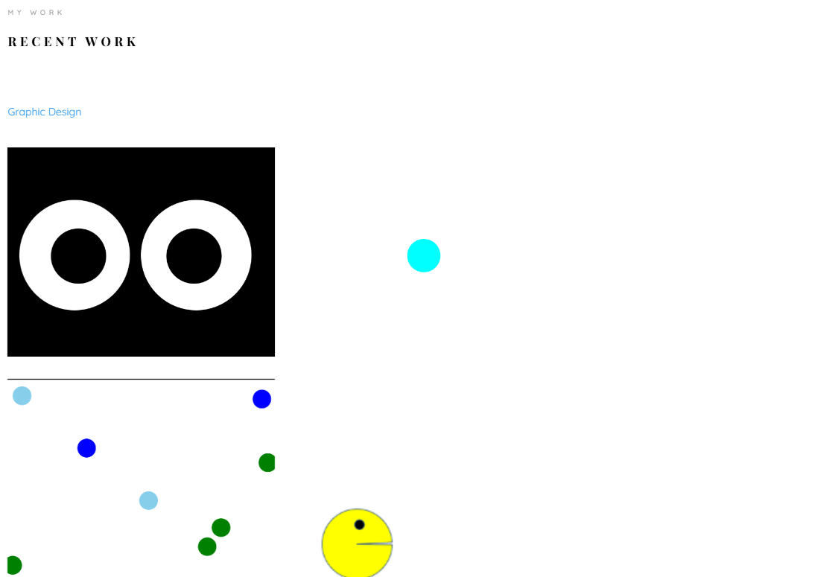

**Source Code**

## HTML:

<!-- ==================== PROJECTS ==================== -->

<section class="colorlib-work" data-section="work">

<div class="colorlib-narrow-content">

<div class="row">

<div class="col-md-6 col-md-offset-3 col-md-pull-3 animate-box" data-animate-effect="fadeInLeft">

<span class="heading-meta">My Work</span>

<h2 class="colorlib-heading animate-box">Recent Work</h2>

</div>

</div>

<div class="row row-bottom-padded-sm animate-box" data-animate-effect="fadeInLeft">

<div class="col-md-12">

<p class="work-menu"><span><a href="#" class="active">Graphic Design</a></span> </p>

</div>

</div>

<div class="row">

<div class="col-md-6 animate-box" data-animate-effect="fadeInLeft">

<div class="project" style="background-image: url(images/eyeball.png);">

<div class="desc">

<div class="con">

<h3>Work 01</h3>

<span>Eye ball</span>

<p class="icon">

<a href="https://pratheep-t2003.github.io/Eyes-ball/" type="">

<span>

<i class="icon-github"></i>

</span>

</a>

<span><a href="https://github.com/Pratheep-T2003/Eyes-ball" ><i class="icon-eye"></i> Read me</a></span>

</p>

</div>

</div>

</div>

</div>

<div class="col-md-6 animate-box" data-animate-effect="fadeInRight">

<div class="project" style="background-image: url(images/Screenshot\ 2024-10-13\ 132519.png);">

<div class="desc">

<div class="con">

<h3>Work 02</h3>

<span>Single ball</span>

<p class="icon">

<a href="https://pratheep-t2003.github.io/singleball/" type="">

<span>

<i class="icon-github"></i>

</span>

</a>

<span><a href="https://github.com/Pratheep-T2003/ball"><i class="icon-eye"></i> Read me</a></span>

</p>

</div>

</div>

</div>

</div>

<div class="col-md-6 animate-box" data-animate-effect="fadeInTop">

<div class="project" style="background-image: url(images/multiballmoving.png);">

<div class="desc">

<div class="con">

<h3>Work 03</h3>

<span>Multiple ball</span>

<p class="icon">

<a href="https://pratheep-t2003.github.io/ball/ " type="">

<span>

<i class="icon-github"></i>

</span>

</a>

<span>

<a href="https://github.com/Pratheep-T2003/multipleball"><i class="icon-eye"></i> Read me</a></span>

</p>

</div>

</div>

</div>

</div>

<div class="col-md-6 animate-box" data-animate-effect="fadeInBottom">

<div class="project" style="background-image: url(images/movingpacman.png);">

<div class="desc">

<div class="con">

<h3>Work 04</h3>

<span>Pac man</span>

<p class="icon">

<a href="https://pratheep-t2003.github.io/Pacman/" type="">

<span>

<i class="icon-github"></i>

</span>

</a>

<span><a href="https://github.com/Pratheep-T2003/Pacman"><i class="icon-eye"></i> Read me</a></span>

</p>

</div>

</div>

</div>

</div>

<div class="col-md-6 animate-box" data-animate-effect="fadeInLeft">

<div class="project" style="background-image: url(images/multiplepacman.png);">

<div class="desc">

<div class="con">

<h3>Work 05</h3>

<span>Multiple Pacman</span>

<p class="icon">

<a href="https://pratheep-t2003.github.io/multipacman/      " type="">

<span>

<i class="icon-github"></i>

</span>

</a>

<span><a href="https://github.com/Pratheep-T2003/multipacman"><i class="icon-eye"></i> Read me</a></span>

</p>

</div>

</div>

</div>

</div>

<div class="col-md-6 animate-box" data-animate-effect="fadeInRight">

<div class="project" style="background-image: url(images/botson.png);">

<div class="desc">

<div class="con">

<h3>Work 06</h3>

<span>Most common words</span>

<p class="icon">

<a href="https://pratheep-t2003.github.io/Boston/" type="">

<span>

<i class="icon-github"></i>

</span></a>

<span><a href="https://github.com/Pratheep-T2003/Boston"><i class="icon-eye"></i> Read me</a></span>

</p>

</div>

</div>

</div>

</div>

<div class="col-md-6 animate-box" data-animate-effect="fadeInRight">

<div class="project" style="background-image: url(images/map\ live.png);">

<div class="desc">

<div class="con">

<h3>Work 07</h3>

<span>Map</span>

<p class="icon">

<a href="https://pratheep-t2003.github.io/Maps/" type="">

<span>

<i class="icon-github"></i>

</span>

</a>

<span><a href="https://github.com/Pratheep-T2003/Maps"><i class="icon-eye"></i> Read me</a></span>

</p>

</div>

</div>

</div>

</div>

</div>

<!-- <div class="row">

<div class="col-md-12 animate-box">

<p><a href="#" class="btn btn-primary btn-lg btn-load-more">Load more <i class="icon-reload"></i></a></p>

</div>

</div> -->

</div>

</section>

## CSS:

/*=============== PROJECTS ===============*/

.project {

  background-size: cover;

  background-position: center center;

  background-repeat: no-repeat;

  position: relative;

  height: 300px;

  width: 100%;

  display: block;

  margin-bottom: 30px; }

  .project .desc {

    position: absolute;

top: 0;

bottom: 0;

left: 0;

right: 0;

background: #2c98f0;

opacity: 0;

-webkit-transition: 0.3s;

-o-transition: 0.3s;

transition: 0.3s; }

.project .desc .con {

padding: 20px;

display: block;

position: relative;

height: 300px; }

.project .desc .con .icon {

position: absolute;

bottom: 20px;

left: 20px;

right: 20px; }

.project .desc .con .icon span {

display: inline;

padding-right: 5px; }

.project .desc .con .icon span a {

color: #333333;

padding: 5px;

background: rgba(255, 255, 255, 0.5);

-webkit-border-radius: 4px;

-moz-border-radius: 4px;

-ms-border-radius: 4px;

border-radius: 4px; }

.project .desc .con .icon i {

font-size: 16px;

color: #333333; }

.project .desc h3 {

font-family: "Quicksand", Arial, sans-serif;

font-size: 16px;

font-weight: 500;

text-transform: uppercase;

letter-spacing: 1px;

-webkit-transition: -webkit-transform 0.3s, opacity 0.3s;

-webkit-transition: opacity 0.3s, -webkit-transform 0.3s;

transition: opacity 0.3s, -webkit-transform 0.3s;

-o-transition: transform 0.3s, opacity 0.3s;

transition: transform 0.3s, opacity 0.3s;

transition: transform 0.3s, opacity 0.3s, -webkit-transform 0.3s;

-webkit-transform: translate3d(0, -15px, 0);

transform: translate3d(0, -15px, 0);

margin-bottom: 15px; }

.project .desc h3 a {

color: #fff; }

.project .desc span {

display: block;

color: rgba(255, 255, 255, 0.7);

font-size: 13px;

-webkit-transition: -webkit-transform 0.3s, opacity 0.3s;

-webkit-transition: opacity 0.3s, -webkit-transform 0.3s;

transition: opacity 0.3s, -webkit-transform 0.3s;

-o-transition: transform 0.3s, opacity 0.3s;

transition: transform 0.3s, opacity 0.3s;

transition: transform 0.3s, opacity 0.3s, -webkit-transform 0.3s;

-webkit-transform: translate3d(0, 15px, 0);

transform: translate3d(0, 15px, 0); }

.project .desc span a {

color: #000; }

@media screen and (max-width: 768px) {

.project .desc {

opacity: 1;

background: rgba(0, 0, 0, 0.4); }

.project .desc h3 {

font-style: 28px;

-webkit-transform: translate3d(0, 0, 0);

transform: translate3d(0, 0, 0);

color: #000; }

.project .desc span {

-webkit-transform: translate3d(0, 0, 0);

transform: translate3d(0, 0, 0); } }

.project:hover .desc {

opacity: 1; }

.project:hover .desc h3 {

-webkit-transform: translate3d(0, 0, 0);

transform: translate3d(0, 0, 0); }

.project:hover .desc span {

-webkit-transform: translate3d(0, 0, 0);

transform: translate3d(0, 0, 0); }

* 1. **Navigation Bar**

### Desktop View



Figure-3.3.1

**Description:**

The Figure-3.3.1 are the samples of navigation bar in both desktop View.This was a user-friendlymethod only, so the user can easily use the features.

**Source Code**

## HTML:

<!--==================== NAVIGATION====================-->

<aside id="colorlib-aside" role="complementary" class="border js-fullheight">

<div class="text-center">

<div class="author-img" style="background-image: url(images/pratheep.jpg);"></div>

<h1 id="colorlib-logo"><a href="index.html">Pratheep </a></h1>

</div>

<nav id="colorlib-main-menu" role="navigation" class="navbar">

<div id="navbar" class="collapse">

<ul>

<li class="active"><a href="#" data-nav-section="home">Home</a></li>

<li><a href="#" data-nav-section="about">About</a></li>

<li><a href="#" data-nav-section="skills">Skills</a></li>

<li><a href="#" data-nav-section="education">Education</a></li>

<li><a href="#" data-nav-section="work">Work</a></li>

<li><a href="#" data-nav-section="contact" >Contact</a></li>

</ul>

</div>

</nav>

</aside>

## CSS:

/*=============== NAVIGATION ===============*/

#colorlib-aside {

padding-top: 3em;

padding-bottom: 40px;

float: left;

width: 300px;

position: fixed;

overflow-y: scroll;

z-index: 1001;

background: #f2f3f7;

-webkit-transition: 0.5s;

-o-transition: 0.5s;

transition: 0.5s; }

@media screen and (max-width: 768px) {

#colorlib-aside {

width: 300px;

-moz-transform: translateX(-300px);

-webkit-transform: translateX(-300px);

-ms-transform: translateX(-300px);

-o-transform: translateX(-300px);

transform: translateX(-300px);

padding-top: 4em; } }

#colorlib-aside .author-img {

width: 150px;

height: 150px;

margin: 0 auto;

margin-bottom: 30px;

-webkit-border-radius: 50%;

-moz-border-radius: 50%;

-ms-border-radius: 50%;

border-radius: 50%; }

#colorlib-aside .position {

display: block;

margin-bottom: 2em;

font-size: 12px;

text-transform: uppercase; }

#colorlib-aside #colorlib-logo {

text-align: right;

font-weight: 700;

font-size: 22px;

margin-bottom: .5em;

display: block;

width: 100%; }

#colorlib-aside #colorlib-logo a {

display: block;

text-align: center;

color: #000;

padding-right: .3em; }

#colorlib-aside #colorlib-main-menu {

display: block;

width: 100%; }

#colorlib-aside #colorlib-main-menu .collapse {

display: block !important; }

#colorlib-aside #colorlib-main-menu ul {

text-align: center;

margin: 0;

padding: 0; }

@media screen and (max-width: 768px) {

#colorlib-aside #colorlib-main-menu ul {

margin: 0 0 2em 0; } }

#colorlib-aside #colorlib-main-menu ul li {

margin: 0 0 10px 0;

padding: 0;

list-style: none;

font-size: 12px;

font-weight: 500;

text-transform: uppercase;

letter-spacing: 1px; }

#colorlib-aside #colorlib-main-menu ul li a {

color: rgba(0, 0, 0, 0.7);

text-decoration: none;

position: relative;

padding: 10px 0;

font-family: "Quicksand", Arial, sans-serif;

-webkit-transition: 0.3s;

-o-transition: 0.3s;

transition: 0.3s; }

#colorlib-aside #colorlib-main-menu ul li a:after {

content: "";

position: absolute;

height: 1px;

bottom: 7px;

left: 0;

right: 0;

background-color: #2c98f0;

visibility: hidden;

-webkit-transform: scaleX(0);

-moz-transform: scaleX(0);

-ms-transform: scaleX(0);

-o-transform: scaleX(0);

transform: scaleX(0);

-webkit-transition: all 0.3s cubic-bezier(0.175, 0.885, 0.32, 1.275);

-moz-transition: all 0.3s cubic-bezier(0.175, 0.885, 0.32, 1.275);

-ms-transition: all 0.3s cubic-bezier(0.175, 0.885, 0.32, 1.275);

-o-transition: all 0.3s cubic-bezier(0.175, 0.885, 0.32, 1.275);

transition: all 0.3s cubic-bezier(0.175, 0.885, 0.32, 1.275); }

#colorlib-aside #colorlib-main-menu ul li a:hover {

text-decoration: none;

color: black; }

#colorlib-aside #colorlib-main-menu ul li a:hover:after {

visibility: visible;

-webkit-transform: scaleX(1);

-moz-transform: scaleX(1);

-ms-transform: scaleX(1);

-o-transform: scaleX(1);

transform: scaleX(1); }

#colorlib-aside #colorlib-main-menu ul li.active a {

color: #2c98f0; }

#colorlib-aside #colorlib-main-menu ul li.active a:after {

visibility: visible;

-webkit-transform: scaleX(1);

-moz-transform: scaleX(1);

-ms-transform: scaleX(1);

-o-transform: scaleX(1);

transform: scaleX(1); }

#colorlib-aside .colorlib-footer {

font-size: 15px;

text-align: center;

font-weight: 400;

color: rgba(0, 0, 0, 0.5);

padding: 0 20px;

width: 100%; }

@media screen and (max-width: 768px) {

#colorlib-aside .colorlib-footer {

position: relative;

bottom: 0; } }

@media screen and (max-width: 768px) {

#colorlib-aside .colorlib-footer {

position: relative;

bottom: 0; } }

#colorlib-aside .colorlib-footer span {

display: block; }

#colorlib-aside .colorlib-footer ul {

padding: 0;

margin: 0; }

#colorlib-aside .colorlib-footer ul li {

padding: 0;

margin: 0;

display: inline;

list-style: none; }

#colorlib-aside .colorlib-footer ul li a {

color: rgba(255, 255, 255, 0.3);

padding: 4px; }

#colorlib-aside .colorlib-footer ul li a:hover, #colorlib-aside .colorlib-footer ul li a:active, #colorlib-aside .colorlib-footer ul li a:focus {

text-decoration: none;

outline: none;

color: #2c98f0; }

**3.4. Education:**



**Description:**

The above figures are skill page, which contain a subdivision named education about my PG degree ,UG degree , HLC & SSLC during an academic year.

**Source Code:**

## HTML:

<!--==================== EDUCATION====================-->

<section class="colorlib-education" data-section="education">

<div class="colorlib-narrow-content">

<div class="row">

<div class="col-md-6 col-md-offset-3 col-md-pull-3 animate-box" data-animate-effect="fadeInLeft">

<span class="heading-meta">Education</span>

<h2 class="colorlib-heading animate-box">Education</h2>

</div>

</div>

<div class="row">

<div class="col-md-12 animate-box" data-animate-effect="fadeInLeft">

<div class="fancy-collapse-panel">

<div class="panel-group" id="accordion" role="tablist" aria-multiselectable="true">

<div class="panel panel-default">

<div class="panel-heading" role="tab" id="headingOne">

<h4 class="panel-title">

<a data-toggle="collapse" data-parent="#accordion" href="#collapseOne" aria-expanded="true" aria-controls="collapseOne">Master Degree MCA

</a>

</h4>

</div>

<div id="collapseOne" class="panel-collapse collapse in" role="tabpanel" aria-labelledby="headingOne">

<div class="panel-body">

<div class="row">

<div class="col-md-6">

<p>RVS College of Arts and Science Autonomous & Affiliated to Bharathiyar University. </p>

</div>

<div class="col-md-6">

<p>2024 - 2026.</p>

</div>

</div>

</div>

</div>

</div>

<div class="panel panel-default">

<div class="panel-heading" role="tab" id="headingTwo">

<h4 class="panel-title">

<a class="collapsed" data-toggle="collapse" data-parent="#accordion" href="#collapseTwo" aria-expanded="false" aria-controls="collapseTwo">Bachelor of Science in Information Technology

</a>

</h4>

</div>

<div id="collapseTwo" class="panel-collapse collapse" role="tabpanel" aria-labelledby="headingTwo">

<div class="panel-body">

<p> Dr. SNS Rajalakshmi College of Arts and Science  Autonomous & Affiliated to Bharathiyar University.</p>

<div class="col-md-6">

<p>2021 - 2024.</p>

</div>

</div>

</div>

</div>

<div class="panel panel-default">

<div class="panel-heading" role="tab" id="headingThree">

<h4 class="panel-title">

<a class="collapsed" data-toggle="collapse" data-parent="#accordion" href="#collapseThree" aria-expanded="false" aria-controls="collapseThree"> HSLC ARTS CA

</a>

</h4>

</div>

<div id="collapseThree" class="panel-collapse collapse" role="tabpanel" aria-labelledby="headingThree">

<div class="panel-body">

<p>M.N.C. Matriculation Higher Secondary School.</p><p>2019 - 2021</p>

</div>

</div>

</div>

<div class="panel panel-default">

<div class="panel-heading" role="tab" id="headingFour">

<h4 class="panel-title">

<a class="collapsed" data-toggle="collapse" data-parent="#accordion" href="#collapseFour" aria-expanded="false" aria-controls="collapseFour">SSLC

</a>

</h4>

</div>

<div id="collapseFour" class="panel-collapse collapse" role="tabpanel" aria-labelledby="headingFour">

<div class="panel-body">

<p>M.N.C. Matriculation Higher Secondary School.</p><p>2014 - 2019.</p>

</div>

</div>

</div>

<!-- end of education -->

</div>

</div>

</div>

</div>

</div>

</section>

## CSS:

/*=============== EDUCATION ===============*/

.colorlib-experience,

.colorlib-skills,

.colorlib-education,

.colorlib-work,

.colorlib-about,

.colorlib-contact {

  padding-top: 4em;

  padding-bottom: 9em;

  clear: both;

  width: 100%;

  display: block; }

  @media screen and (max-width: 768px) {

    .colorlib-experience,

    .colorlib-skills,

    .colorlib-education,

    .colorlib-work,

    .colorlib-about,

  .colorlib-contact {

      padding-top: 5em;

      padding-bottom: 8em; } }

**3.5. SKILLS:**

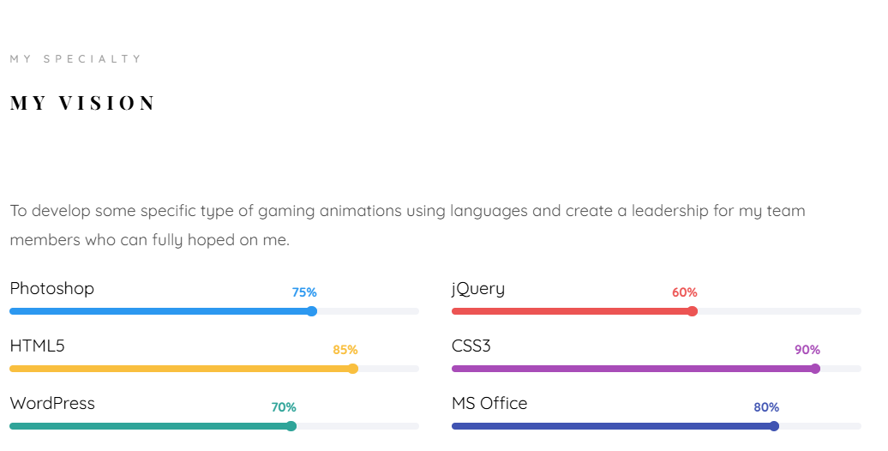

**Source Code:**

## HTML:

<!--==================== Skills ====================-->

<section class="colorlib-skills" data-section="skills">

<div class="colorlib-narrow-content">

<div class="row">

<div class="col-md-6 col-md-offset-3 col-md-pull-3 animate-box" data-animate-effect="fadeInLeft">

<span class="heading-meta">My Specialty</span>

<h2 class="colorlib-heading animate-box">My Vision</h2>

</div>

</div>

<div class="row">

<div class="col-md-12 animate-box" data-animate-effect="fadeInLeft">

<p>To develop some specific type of gaming animations using languages and create a leadership for my team members who can fully hoped on me.</p>

</div>

<div class="col-md-6 animate-box" data-animate-effect="fadeInLeft">

<div class="progress-wrap">

<h3>Photoshop</h3>

<div class="progress">

<div class="progress-bar color-1" role="progressbar" aria-valuenow="75"

aria-valuemin="0" aria-valuemax="100" style="width:75%">

<span>75%</span>

</div>

</div>

</div>

</div>

<div class="col-md-6 animate-box" data-animate-effect="fadeInRight">

<div class="progress-wrap">

<h3>jQuery</h3>

<div class="progress">

<div class="progress-bar color-2" role="progressbar" aria-valuenow="60"

aria-valuemin="0" aria-valuemax="100" style="width:60%">

<span>60%</span>

</div>

</div>

</div>

</div>

<div class="col-md-6 animate-box" data-animate-effect="fadeInLeft">

<div class="progress-wrap">

<h3>HTML5</h3>

<div class="progress">

<div class="progress-bar color-3" role="progressbar" aria-valuenow="85"

aria-valuemin="0" aria-valuemax="100" style="width:85%">

<span>85%</span>

</div>

</div>

</div>

</div>

<div class="col-md-6 animate-box" data-animate-effect="fadeInRight">

<div class="progress-wrap">

<h3>CSS3</h3>

<div class="progress">

<div class="progress-bar color-4" role="progressbar" aria-valuenow="90"

aria-valuemin="0" aria-valuemax="100" style="width:90%">

<span>90%</span>

</div>

</div>

</div>

</div>

<div class="col-md-6 animate-box" data-animate-effect="fadeInLeft">

<div class="progress-wrap">

<h3>WordPress</h3>

<div class="progress">

<div class="progress-bar color-5" role="progressbar" aria-valuenow="70"

aria-valuemin="0" aria-valuemax="100" style="width:70%">

<span>70%</span>

</div>

</div>

</div>

</div>

<div class="col-md-6 animate-box" data-animate-effect="fadeInRight">

<div class="progress-wrap">

<h3>MS Office</h3>

<div class="progress">

<div class="progress-bar color-6" role="progressbar" aria-valuenow="80"

aria-valuemin="0" aria-valuemax="100" style="width:80%">

<span>80%</span>

</div>

</div>

</div>

</div>

</div>

</div>

# Chapter-4 Style Score

* 1. **Styles**

**Source Code:**

HTML CODE:

## <link rel="shortcut icon" href="favicon.ico">

## <link href="https://fonts.googleapis.com/css?family=Quicksand:300,400,500,700" rel="stylesheet">

## <link href="https://fonts.googleapis.com/css?family=Playfair+Display:400,400i,700" rel="stylesheet">

* 1. **Style Links**

<!--=============== FAVICON ===============-->

<link rel="shortcut icon" href="assets/img/icons8-circled-v-48.png" type="image/x-icon">

<!--=============== REMIXICONS ===============-->

<link rel="stylesheet" href="https://cdnjs.cloudflare.com/ajax/libs/remixicon/3.4.0/remixicon.css" crossorigin="">

<!--=============== CSS ===============-->

<link rel="stylesheet" href="style-switcher.css">

    <link rel="stylesheet" href="intro.css">

    <link rel="stylesheet" href="color-1.css">

    <link rel="stylesheet" href="https://cdnjs.cloudflare.com/ajax/libs/font-awesome/5.15.4/css/all.min.css">

<!--=============== JS ===============-->

    <script src="style-switcher.js"></script>

# Chapter 5:

**Website include the following Information**

**5.1 Project links to GitHub:**

**Project-1**

Title: **BALL MOVEMENT**

Link: [BALL (pratheep-t2003.github.io)](https://pratheep-t2003.github.io/singleball/)

* + - **Project Description:**

This HTML page displays a continuous bouncing red ball animation within a rectangular area controlled by JavaScript using the setInterval function with a 500- millisecond interval.

**Project-2**

Title: **RANDOM BALL WALK**

Link[: [Document (pratheep-t2003.github.io)](https://pratheep-t2003.github.io/ball/)](https://vignesh-mca23.github.io/Random_Ball/)

* + - **Project Description:**

Elevate the animation by enabling user input for modifying the ball's movement, incorporating elementslike keyboard and mouse controls, as well as introducing obstacles or targets to enhance interactivity.

#### PROJECT-3

Title: **PAC-MAN**

Link: [Pacman (pratheep-t2003.github.io)](https://pratheep-t2003.github.io/Pacman/)

* + - **Project Description:**

This HTML page features a Pac-Man animation moving horizontally within a container, controlled by JavaScript for direction, mouth animation, and boundary reversal, with a continuous animation loop triggered by setInterval every 100 milliseconds.

**PROJECT-4**

Title: **BOSTON CITY DATA**

Link: [Document (pratheep-t2003.github.io)](https://pratheep-t2003.github.io/Boston/)

* + - **Project Description:**

This JavaScript program retrieves and displays information about the top five earning employeesin Boston, providing key details for each employee.

**PROJECT-5**

Title: **EYE BALL MOVEMENT**

Link: [coding Assignment 7 (pratheep-t2003.github.io)](https://pratheep-t2003.github.io/Eyes-ball/)

* + - **Project Description:**

This HTML document displays the eye ball which can moves towards the cursor pointer at

Any position you can move.

**PROJECT-6**

Title: **MULTIPLE PACMAN**

Link: [Document (pratheep-t2003.github.io)](https://pratheep-t2003.github.io/multipacman/)

* + - **Project Description:**

This HTML document displays the click on start button the pacman create randomly and

Click on move button it will move forward direction .

**PROJECT-7**

Title: **MAP**

Link: [Guides (pratheep-t2003.github.io)](https://pratheep-t2003.github.io/Maps/)

* + - **Project Description:**

This HTML document displays the map moving from live place to destination and show

In between stop in it.

**PROJECT-8**

Title: **HANOI TOWER**

Link: https://pratheep-t2003.github.io/Hanoi/

* + - **Project Description:**

This HTML document displays the Hanoi tower which can move the number from one

stand to another

# Chapter-6:

**Bootstrap**

**6.1 Uses of Bootstrap:**

**Source Code**

<!-- Bootstrap JS and Popper.js (required for Bootstrap) -->

<script src="https://code.jquery.com/jquery-3.3.1.slim.min.js"></script>

<script src="https://cdnjs.cloudflare.com/ajax/libs/popper.js/1.14.7/umd/popper.min.js"></script>

<script src="https://stackpath.bootstrapcdn.com/bootstrap/4.3.1/js/bootstrap.min.js"></script>

**Description:**

I have used bootstrap in this website as a separate file. Which was a built in CSS file, so wecan use it to reduce our time and also it carries a (N) number of designs. So, I had linked them to the code in HTML.

CSS

<style> body {

background: linear-gradient(to right, #11998e, #38ef7d); font-family: 'Arial', sans-serif;

color: #999; /* Light gray text color */ margin: 0;

padding: 0;

}

.container {

background-color: rgba(255, 255, 255, 0.8); border-radius: 15px;

box-shadow: 0 0 20px rgba(0, 0, 0, 0.2); padding: 50px;

margin: 50px auto; max-width: 1200px;

}

.carousel-inner {

border: 10px solid #007bff; border-radius: 15px; overflow: hidden;

box-shadow: 0 0 20px rgba(0, 0, 0, 0.2);

}

.carousel-item img { width: 100%; height: auto;

border-radius: 15px;

}

h1 {

color: #db1414; /* Deep blue heading color */ text-align: center;

margin-bottom: 30px; text-transform: uppercase; letter-spacing: 2px;

font-size: 48px; font-weight: bold;

text-shadow: 2px 2px 4px rgba(0, 0, 0, 0.3);

}

p {

color: #999; /* Light gray text color */ font-size: 18px;

}

.carousel-control-prev, .carousel-control-next { width: 5%;

}

.carousel-control-prev-icon, .carousel-control-next-icon { background-color: #01050a;

border-radius: 50%; padding: 10px; color: #ffffff;

}

.carousel-control-prev:hover, .carousel-control-next:hover { background-color: #0056b3;

}

.carousel-caption {

background-color: rgba(0, 123, 255, 0.7); border-radius: 15px;

padding: 20px; bottom: 0;

width: 100%; color: #ffffff; text-align: center; font-size: 18px;

}

</style>

# Chapter 7:

**Project README**

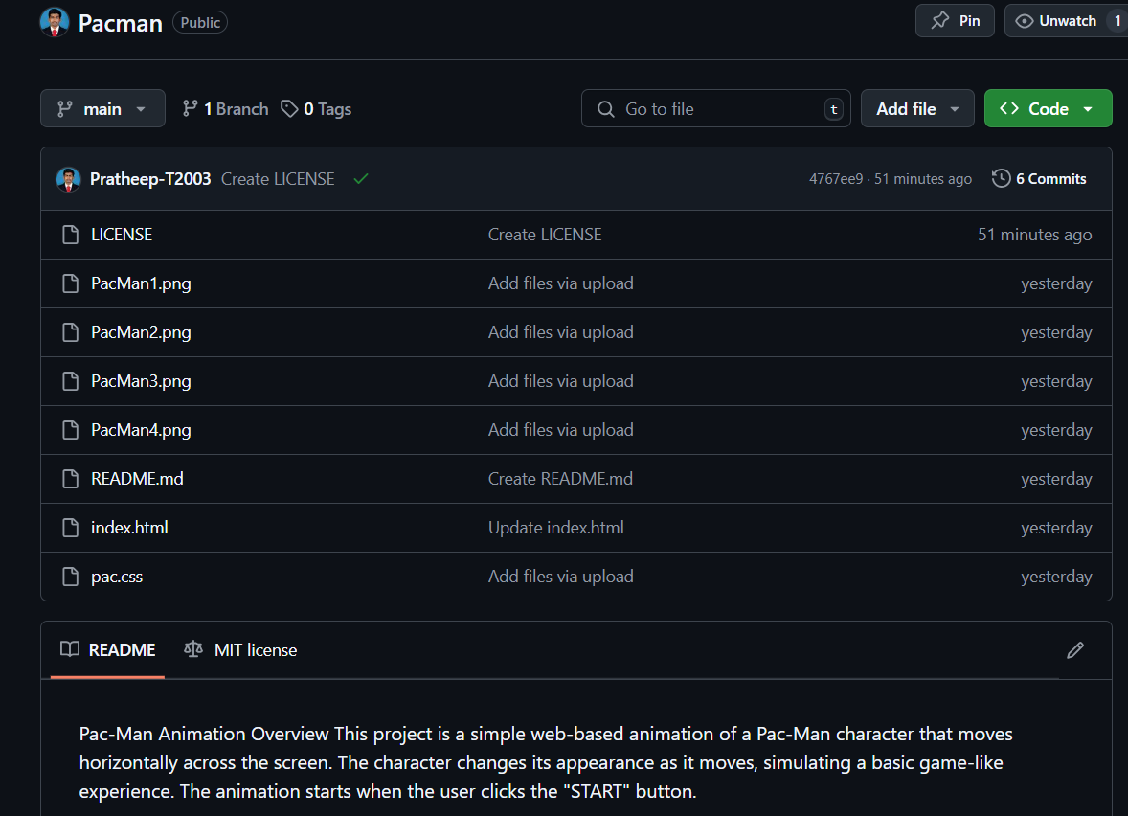

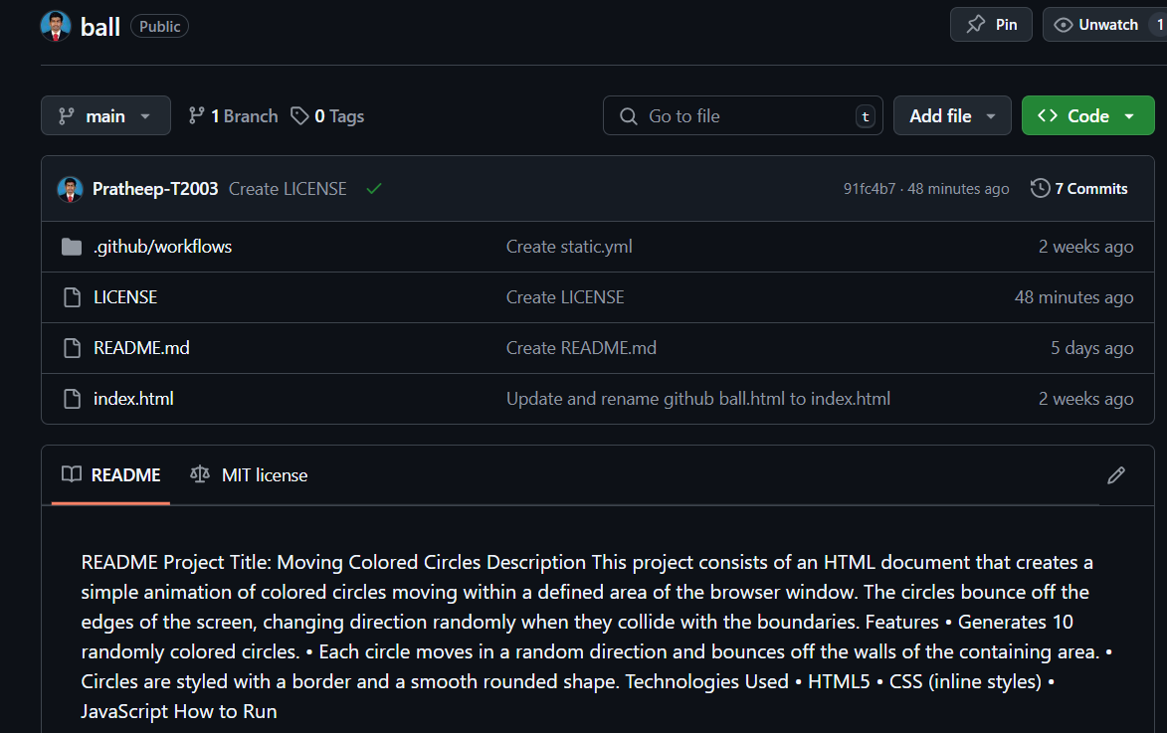

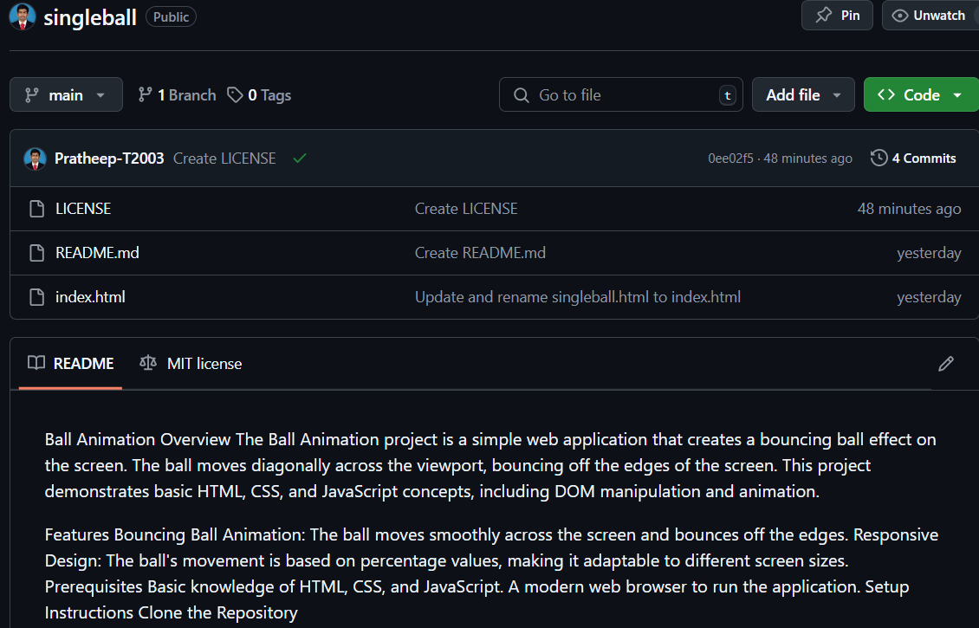

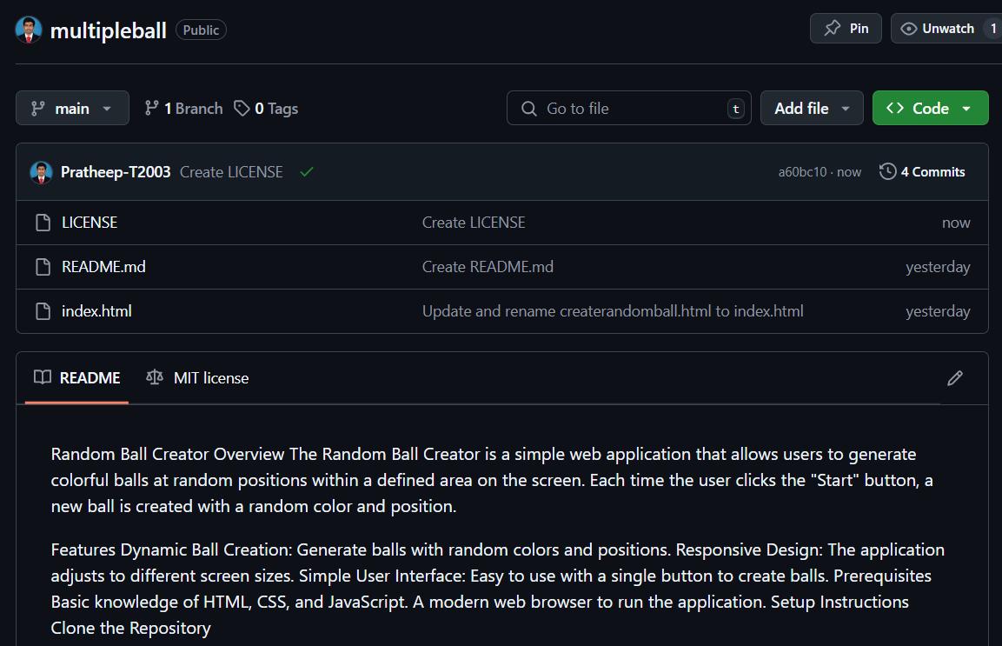

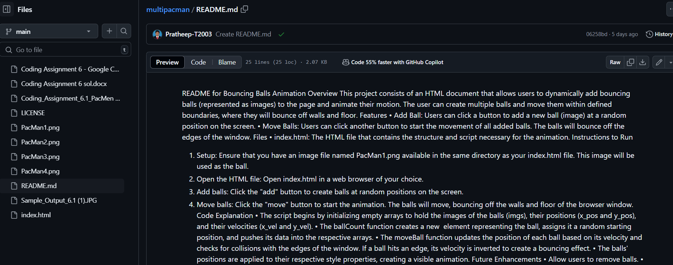

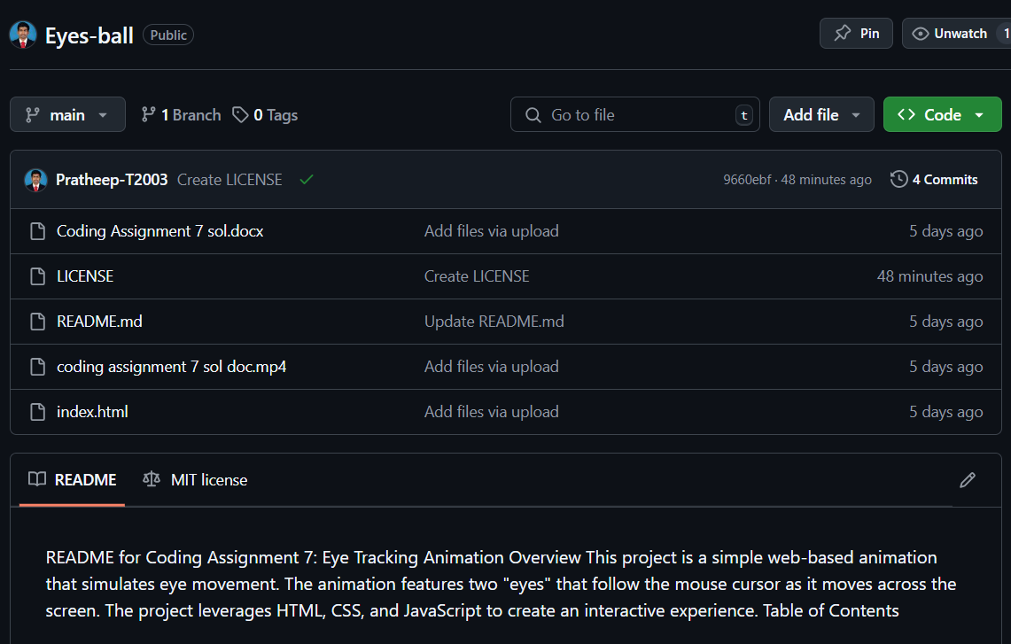

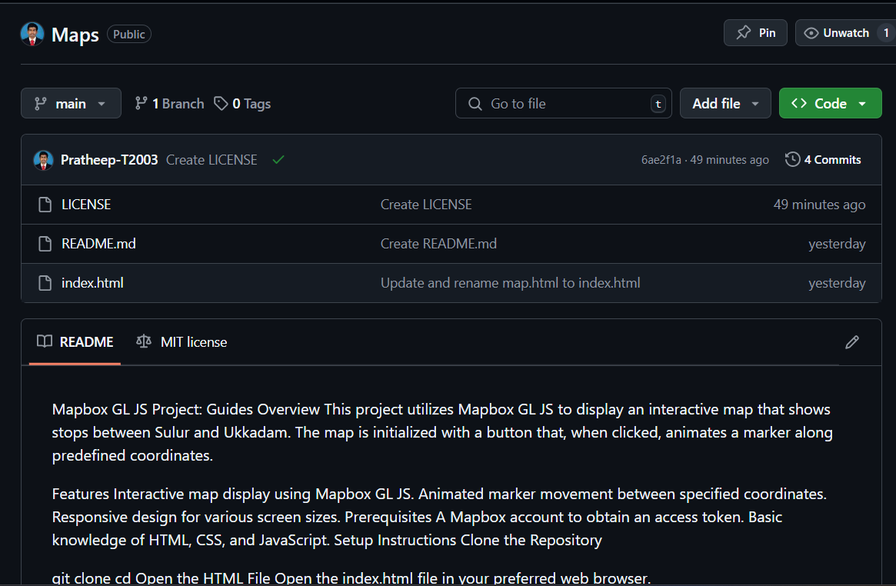

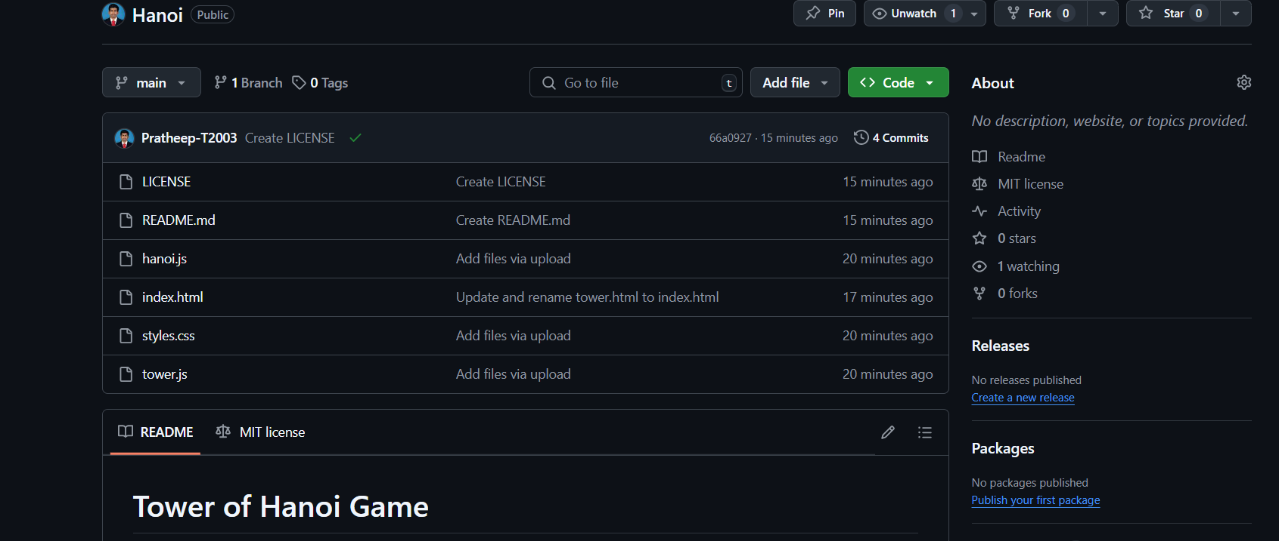

**Description:**

The above figures are the screenshot of project README files (Description, steps to run, futureimprovement) in a desktop view.